Nivea for Men Image Analysis
Name
Institution affiliation
Date

Introduction
Businesses depend greatly on different forms of advertisements including pictorial advertisement. Pictorials advertisements can be in form of videos or printed media on different products. In daily life, people come across images put on products to advertise them. These images portray different meanings to reach different genders and ages of people. Normally, they persuade and enlighten customers to purchase the product or gain access to its services. Advertisements have in most cases influenced customers to purchase a product or a service since they have a convincing effect to the viewer. Images over the past have become increasingly used because they have a positive and attractive to people and most companies have employed the use of this form of advertisement in attracting new customers for their new products and services (Abadie, 2011). For any company to use any image to advertise a product, it is essential to analyze critically the image and understand its implication to the customers. The essay aims at breaking down the image into the audience, context, and purpose of the Nivea for men advertisement, thus determining the effectiveness of the image. Therefore, to plainly comprehend the image, it is essential to put into consideration the image analysis with concepts of color, tone, text and arrangement of the image. An analysis of “think about your writing” will also be provided after the image analysis.

Image Analysis
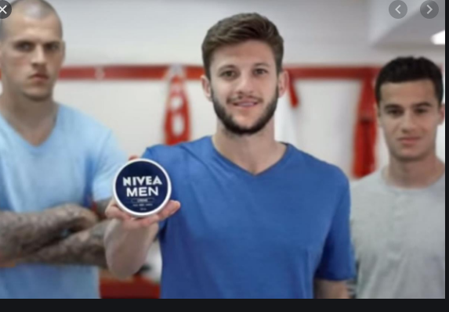
Image fromhttps://www.theguardian.com/tv-and-radio/2015/sep/05/adam-lallana-nivea-advert

Audience
Audience is defined as participants on a public event. Each company produces a product for specific people. The main audiences targeted in this advertisement are men. Most men being football fans, the image of known football players used in this image can reach most men. The background of the picture therefore contains an image of Liverpool FC footballers with the one in the middle holding the Nivea oil product with the label “Nivea Men”. English football being a global completion these image is used to advertises the Nivea men moisturizing cream globally(Golby, 2015). The product leaves the skin moisturized and it’s non-greasy and fast absorbing. These features make the product appealing to all men of different skin types and textures.

Context
In the image above, the most important item is the Nivea men cream. Based on its popularity worldwide, the Nivea brand specializes in skin care products and Nivea cream for men is one of the most known of its products. According to (Lakhani et al, 2014), Nivea is best recognized for its finest valued products and the thorough R&D process that has resulted to the production of successful products. Nivea brand has produced suitable creams for hands, face and the body to prevent skin dehydration and dryness. Additionally, the Nivea men cream can also be purchased by women for on behalf of their loved ones when doing their shopping.

Purpose
The purpose of an advertisement has to be clear and easily understood and most are meant to improve the sales of the product. The purpose of this image is to encourage the majority of the men who are the target to purchase Nivea cream. The men in the image above show happiness and have good looking skin texture. With this image, the Nivea men body cream receives a meaning that is shared across cultures and generates recognition. Research done by (Haddad et al, 2015) indicates that a high-quality advertisement image outcome to positive and significant acknowledgment.

Color and text
Other strategies used in the image are arrangement color ant text. In the above image, there is a substantial arrangement of three men but the most focus is on the middle man holding the Nivea Men cream. Then man is closer so that customers can view the image of the cream. The color of the cream on the other hand is blue and white so as to enhance readability of the text and closely matches with the dressing of the men. The intend of color is to arouse visual manifestation of the printed image(Bonanomi et al 2012). In addition, the text of the products is bright and has correct font size on the “Nivea Men.” Different target groups view the advertising image of same product differently and accuracy is needed to avoid confusion(Backhaus et al, 2007)

Conclusion
Generally, advertisements images are great in acquiring quick and many customers for new products when they use renown and public figures such as celebrities as in the case of the above image. For the image to be effective in its intent, it has to have the right color and text font size which will enable it to portray the right and intended message and reach the right consumers. Conclusively, the ad image above is compelling as Nivea is a brand that has created awareness over the past years. It is most likely guaranteed that the Nivea men cream advertisement is effective as they take advantage of the brand name. The ad is effective as the target audience is well-identified through the image.

Think about Your Writing
Question I
The time spent revising the draft is about five hours. The revision strategies used include addition of details, deletion of unnecessary points and words and re-arrangement of words and sentences for clarification. Addition of information worked best. More research done improved the information presented in the essay. The additional evidences support the thesis statement and have met at most the requirements of the essay.
Question 2
The revision process made the essay more presentable and adoptable. One can easily understand the content of the essay. More relevant details have been added compared to the drafted essay. The orders of the paragraphs have changed a little with an addition of one paragraph with abetter flow of information. As a writer, the writing process is smooth when the same order of presenting information is followed according to the draft. Addition of information is also key in presenting a good essay. The entire process revealed that writing essays is dependent on a nicely drafted work and writing a comprehensive essay from it.

Reference
Abadie, E. A. (2011). Persuasion tactics implemented in multicultural markets: The significance of ethnically tailored advertisements.
Golby, J. (2015, September 5). The new Nivea For Men advert: Adam Lallana takes on the football bullies... with moisturiser. The Guardian. https://www.theguardian.com/tv-and-radio/2015/sep/05/adam-lallana-nivea-advert
Lakhani, K. R., Fuller, J., Bilgram, V., & Friar, G. (2014). Nivea (a).
Haddad, L., Hamza, K., & Xara-Brasil, D. (2015). Archetypes and brand image: an international comparison. Australian Journal of Basic and Applied Sciences, 22-31.
Backhaus, K., & Van Doorn, J. (2007). Consumer Perceptions of Advertising Standardization: A Cross-Country Study of Different Advertising Categories. International Management Review, 3(4).
Bonanomi, C., Marini, D. L., & Rizzi, A. (2012). From printed color to image appearance: tool for advertising assessment. Journal of Electronic Imaging, 21(3), 033016.

